Traffic Management Topics
-------------------------
Load Balancer
Application Gateway
Azure Front Door
Traffic Manager

Azure Load Balancer
What is Azure Load Balancer?
Azure Load Balancer is a service that distributes incoming traffic across multiple virtual machines or backend resources.

What Problem Does It Solve?
Suppose you have:
Internet
↓
VM-1
If VM-1 fails:
Application Down ❌
To avoid this, deploy multiple VMs:
VM-1
VM-2
VM-3
and place a Load Balancer in front of them.
Internet
↓
Load Balancer
↓
VM-1
VM-2
VM-3
Now if one VM fails, traffic is automatically sent to healthy VMs.

Why Do We Need Load Balancer?
High Availability
Keeps applications available even when a VM fails.
Traffic Distribution
Distributes incoming traffic across multiple VMs.
Scalability
Allows adding more VMs as traffic increases.
Fault Tolerance
Removes unhealthy VMs from traffic routing automatically.

Types of Azure Load Balancer
Public Load Balancer
Used for internet-facing applications.
Internet
↓
Public Load Balancer
↓
Web VMs
Examples:
- Websites
- APIs
- Public Applications

Internal Load Balancer
Used for private communication inside a VNet.
App Servers
↓
Internal Load Balancer
↓
Database Servers
Examples:
- Application Tier → Database Tier
- Internal Services
- Backend Applications

Main Components
Frontend IP
The IP address users connect to.
Backend Pool
The group of VMs that receive traffic.
Health Probe
Checks whether backend VMs are healthy.
Load Balancing Rule
Defines how traffic is forwarded from frontend to backend.

AWS Equivalent
Azure Load Balancer ≈ AWS Network Load Balancer (NLB)

Key Point
NSG
→ Decides whether traffic is allowed or denied.
Load Balancer
→ Decides which VM receives the traffic.

Real Example
Users
↓
Load Balancer
↓
Web-VM-1
↓
Web-VM-2
↓
Web-VM-3

If Web-VM-2 fails:
Users
↓
Load Balancer
↓
Web-VM-1
↓
Web-VM-3
Application remains available without downtime.

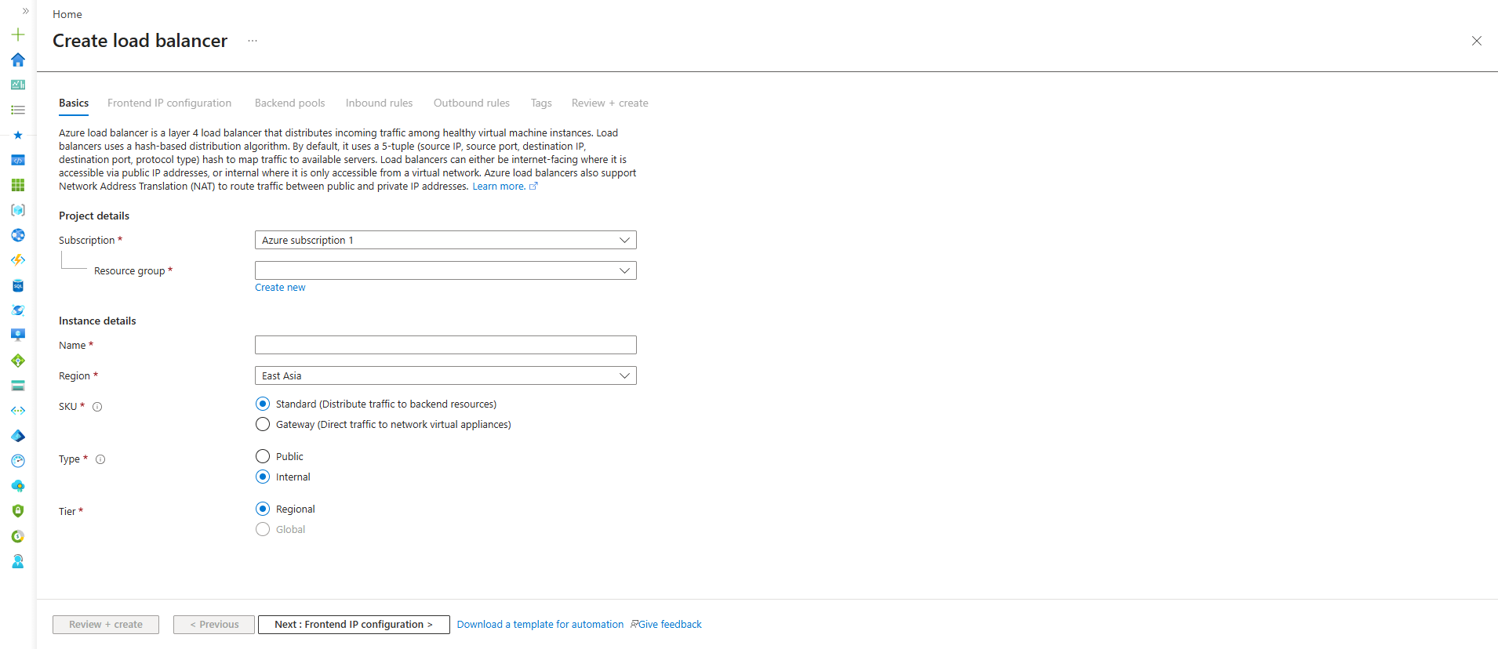
Fill these values
Resource Group : Resource_group_1
Name : web-lb
Region : East Asia
SKU : Standard
Type : Public ← Change from Internal
Tier : Regional

Explain these fields
Resource Group
Definition:
Container that stores Azure resources.
Usage:
Stores Load Balancer and related resources.
If not selected:
Load Balancer cannot be created.

Name
Definition:
Unique name of the Load Balancer.
Usage:
Used to identify the Load Balancer.
Example:
web-lb

Region
Definition:
Azure location where the Load Balancer is deployed.
Usage:
Should match the VM region.
Example:
East Asia

SKU
You have:
Standard
Gateway
Select:
Standard
Definition:
Distributes traffic across backend resources.
Usage:
Used for VMs, VMSS, AKS workloads.
If Gateway selected:
Used for Network Virtual Appliances (advanced networking).

Type
You currently selected:
Internal
Change to:
Public
Reason:
Public:
Internet → Load Balancer → VMs
Internal:
VMs → Load Balancer → Internal Services
For learning, Public is easier.

Tier
Regional
Definition:
Load Balancer exists within one Azure region.
Usage:
Most common option.
Example:
East Asia region only.
Leave Global unchecked.

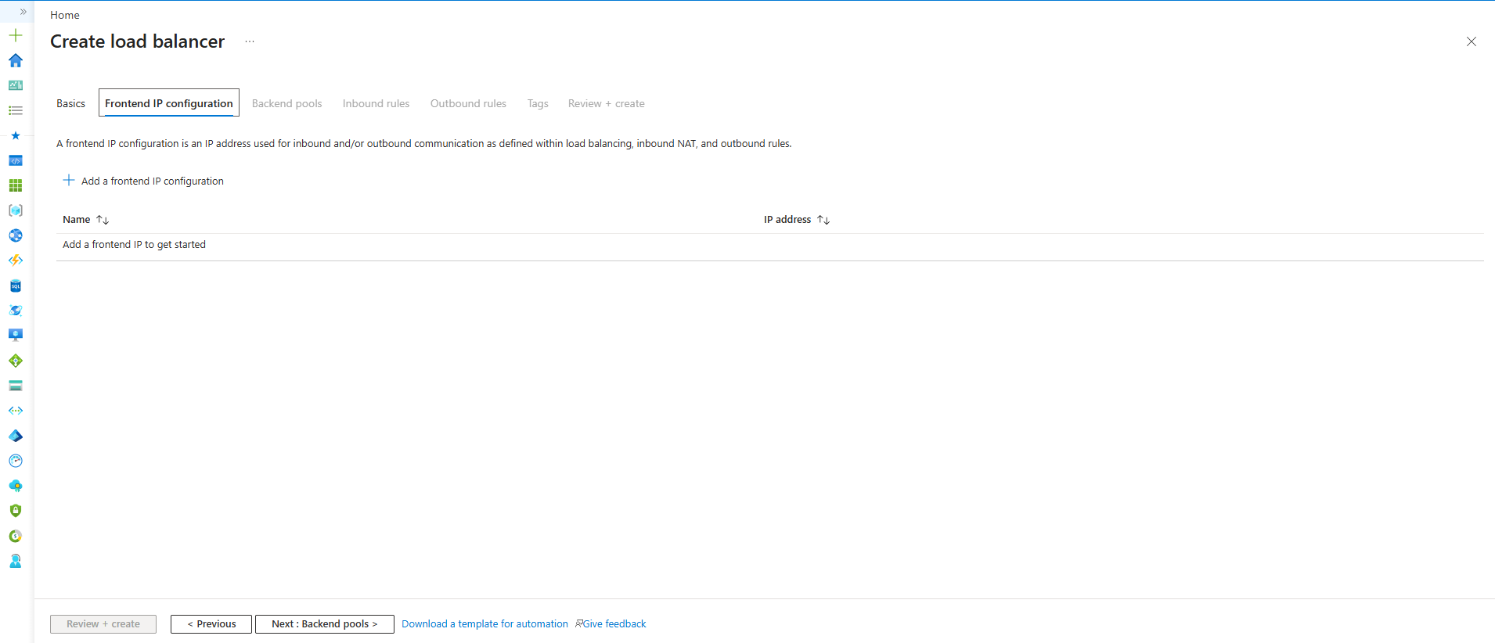
Frontend IP is the public-facing IP address of the Load Balancer. Client requests are received on this IP and then distributed to backend resources based on configured load-balancing rules.
Frontend IP Configuration
Definition:
Frontend IP is the public-facing IP address of the Load Balancer through which users access the application.
Why We Need It:
- Acts as the entry point for incoming traffic.
- Provides a single IP address for users to connect to.
- Receives requests and forwards them to backend resources.
- Hides the actual VM IP addresses from users.
- Enables traffic distribution across multiple backend VMs.
Configuration Fields:
Name
- Unique name for the frontend IP configuration.
- Used to identify the configuration within the Load Balancer.
- Example: frontend-ip
IP Version
- Defines the IP protocol version.
- IPv4 is commonly used for most applications.
- IPv6 is used only when specifically required.
IP Type
- Determines how the frontend IP is assigned.
- IP Address creates a single public IP.
- IP Prefix is used for advanced networking scenarios.
Public IP Address
- Public IP assigned to the Load Balancer.
- Users access the application through this IP.
- Azure can create a new Public IP resource during configuration.
Gateway Load Balancer
- Used to integrate network virtual appliances such as firewalls.
- Supports advanced traffic inspection scenarios.
- Not required for basic Load Balancer deployments.
Traffic Flow
Internet
↓
Frontend IP
↓
Load Balancer
↓
Backend VMs
Key Point
Frontend IP is the address users connect to, while the Load Balancer decides which backend VM receives the traffic.
The simplest understanding is:
Frontend IP = Public IP attached to the Load Balancer
Why do we attach it?
Because users need an address to connect to.
Internet
↓
Frontend IP (Public IP)
↓
Load Balancer
↓
VMs

Without Frontend IP
Internet
↓
Load Balancer
Users don't have any public IP to reach.

With Frontend IP
Internet
↓
52.x.x.x
(Frontend IP)
↓
Load Balancer
↓
VM-1
VM-2
VM-3

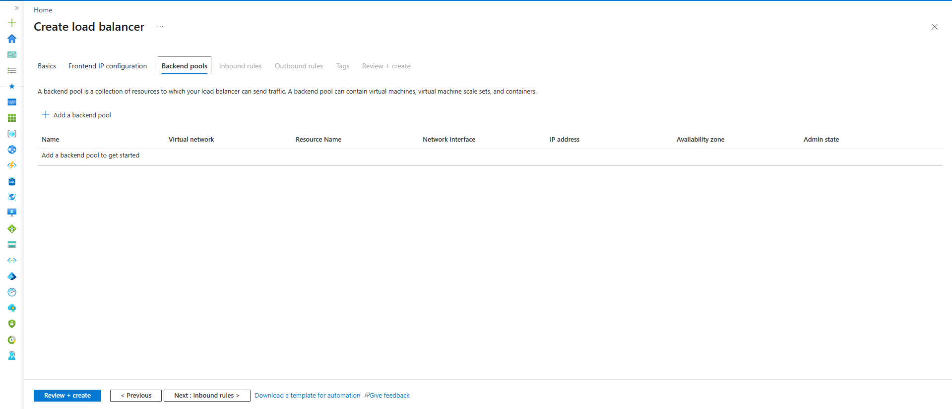
Definition
- Backend Pool is a collection of backend resources that receive traffic from the Load Balancer.
Usage
- Used to group virtual machines or other resources behind a single Load Balancer.
Why We Need It
- Enables traffic distribution across multiple backend resources.
- Provides high availability and scalability.
- Allows the Load Balancer to know where to forward incoming requests.
Examples
- Virtual Machines
- Virtual Machine Scale Sets
- AKS Nodes
- Containers

Easy Understanding
Think of:
Frontend IP = Main Entrance
Load Balancer = Receptionist
Backend Pool = Employees
Customer enters:
Main Entrance
↓
Receptionist
↓
Employee-1
Employee-2
Employee-3
The receptionist decides which employee gets the customer.
Similarly:
Frontend IP
↓
Load Balancer
↓
Backend Pool
↓
VM-1 / VM-2 / VM-3
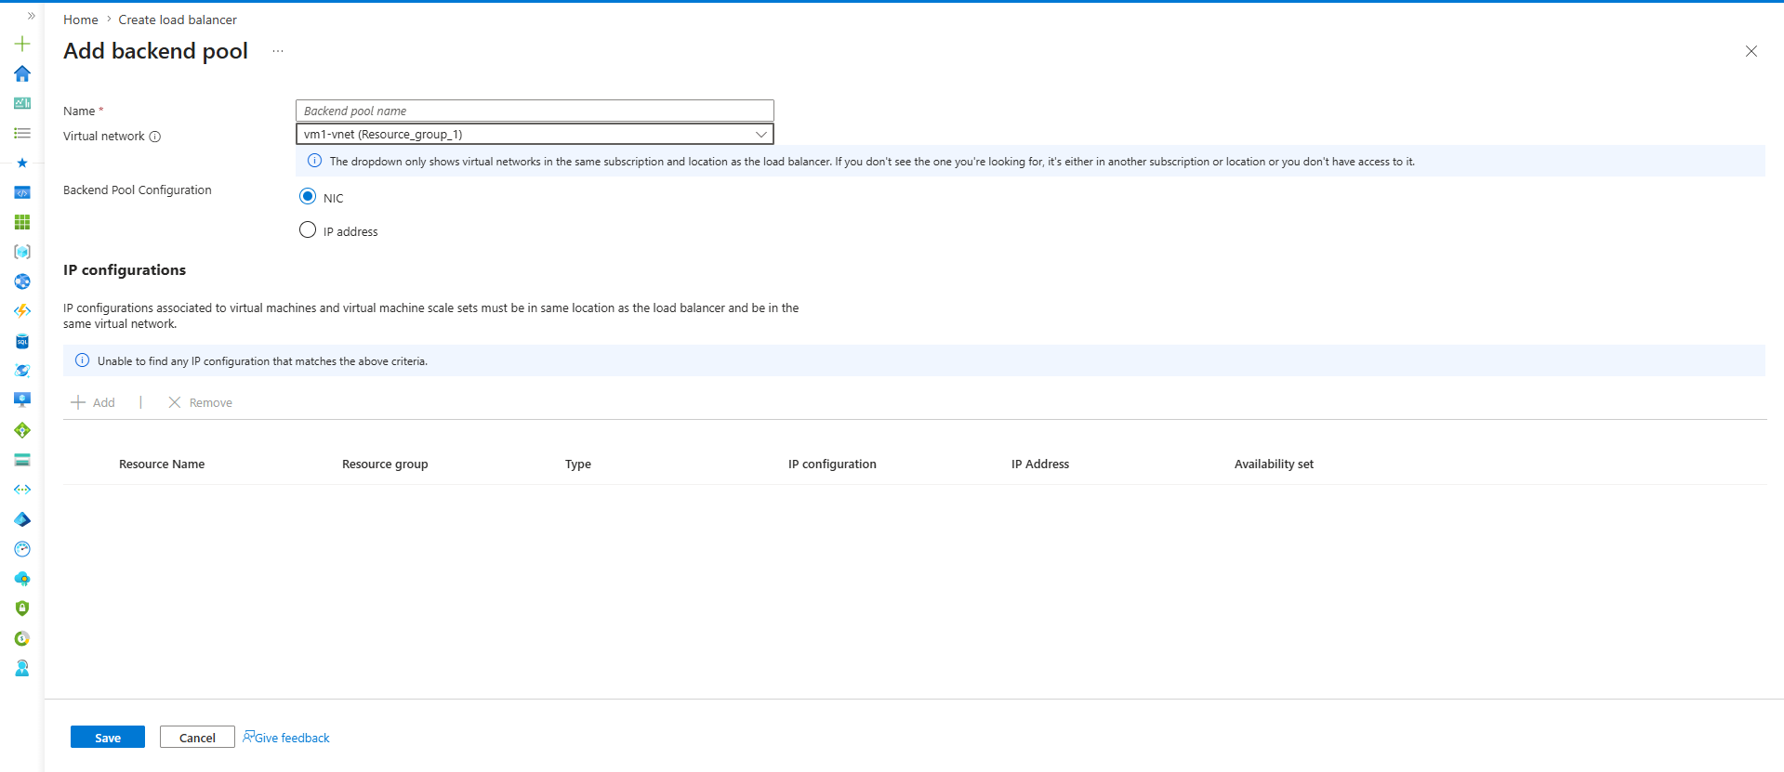
Name
web-backend-pool
Purpose:
Group of VMs that receive traffic.

Virtual Network
Select:
rg_vnet_demo
Backend Pool Configuration
Keep:
NIC
Why?
VM communicates through NIC.
Load Balancer sends traffic to VM NIC.
Remember:
VM
↓
NIC
↓
Subnet

Backend Pool
- Collection of backend resources that receive traffic from the Load Balancer.
- Contains virtual machines, VM scale sets, or container workloads.
- Load Balancer distributes incoming traffic across resources in the Backend Pool.
- Provides scalability and high availability.
- Backend resources are typically added through their NICs.

• NIC Mode: Backend resources are added through their network interfaces. Commonly used for virtual machines.
• IP Address Mode: Backend resources are added using private IP addresses instead of NICs. Typically used in advanced networking scenarios.
• Recommended: Use NIC-based backend pools for virtual machine workloads.

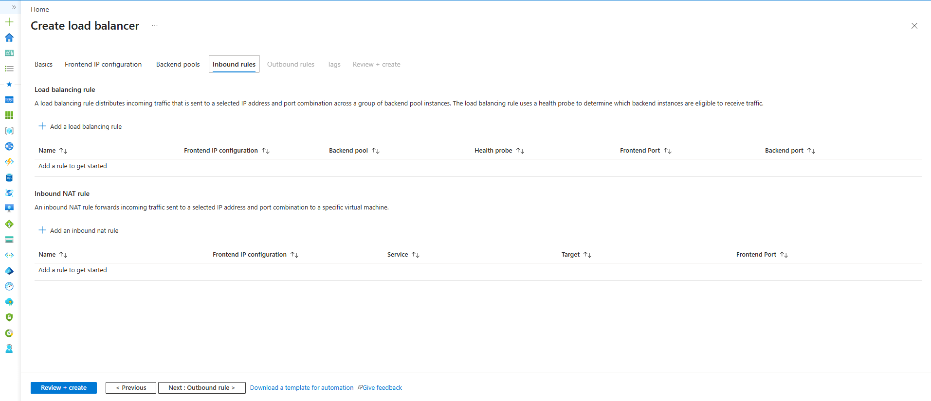
Until now we created:
Frontend IP ✅
Backend Pool ✅
Now Azure asks:
When traffic arrives,
which port should I send it to?
That's what an Inbound Rule does

Load Balancing Rule
- Defines how incoming traffic is forwarded from the Frontend IP to the Backend Pool.
- Maps frontend ports to backend ports.
- Uses Health Probes to identify healthy backend resources.
- Enables traffic distribution across multiple VMs.
- Required for application traffic such as HTTP and HTTPS.
Health Probe
- Continuously monitors backend resource health.
- Sends traffic only to healthy resources.
- Improves application availability.
- Automatically removes failed VMs from traffic routing.
- Re-adds VMs when they become healthy again.
Inbound NAT Rule
- Forwards traffic to a specific VM.
- Used for management access such as SSH or RDP.
- Does not perform load balancing.
- Maps a frontend port to a backend VM port.
- Commonly used for administrative access.

Easy Memory Trick
Load Balancing Rule
→ One IP → Many VMs
Inbound NAT Rule
→ One IP → One VM
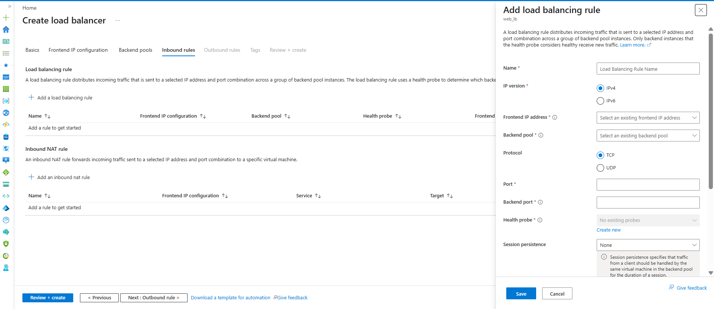

This is the most important concept in Load Balancer.
You already have:
Frontend IP
↓
Load Balancer
↓
Backend Pool
But Azure still doesn't know:
Which port should I listen on?
Which port should I forward to?
Which backend pool should receive traffic?
That's why we need a Load Balancing Rule.

What is a Load Balancing Rule?
A Load Balancing Rule tells Azure:
If traffic comes on this Frontend IP and Port,
send it to this Backend Pool and Port.
Example:
Frontend IP : 52.x.x.x
Frontend Port : 80
Backend Pool : web-backend-pool
Backend Port : 80
Meaning:
User → 52.x.x.x:80
↓
Load Balancer
↓
VM-1:80
VM-2:80
VM-3:80

Why Do We Need It?
Without a rule:
Internet
↓
Load Balancer
Load Balancer doesn't know:
Where should traffic go?
Which backend pool?
Which port?
So traffic stops there.
The rule acts like instructions.

Real Example
Suppose your website runs on:
Port 80
Rule:
Frontend Port = 80
Backend Port = 80
Traffic Flow:
User
↓
52.x.x.x:80
↓
Load Balancer
↓
VM-1:80

Why Is It Under Inbound Rules?
Because this is:
Internet
↓
Azure
traffic.
That is called:
Inbound Traffic
Traffic coming into Azure.
Examples:
User opens website
User calls API
User accesses application

Easy Understanding
Think of a building.
Main Gate
↓
Security Guard
↓
Room 101
Room 102
Room 103
The guard needs instructions:
Visitors for Sales
→ Room 101
Visitors for Support
→ Room 102
That instruction is the:
Load Balancing Rule

One-Line Documentation
Load Balancing Rule defines how incoming traffic received on a Frontend IP and port is distributed to backend resources in a Backend Pool.

Difference Between Load Balancing Rule and Inbound NAT Rule
Load Balancing Rule
One Public IP
↓
Many VMs
Used for:
Websites
APIs
Applications

Inbound NAT Rule
One Public IP
↓
One Specific VM
Used for:
SSH
RDP
Administration
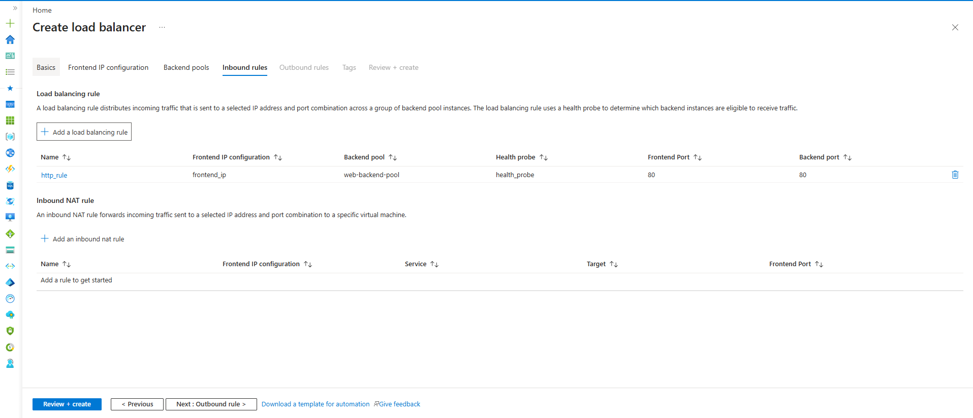
Inbound Rules define how incoming client traffic is processed by the Load Balancer. Load Balancing Rules are used to map frontend ports to backend ports and distribute application traffic to backend resources.
Inbound Rules
↓
Contain Load Balancing Rules
↓
Define application communication flow
↓
Frontend IP → Backend Pool

Documentation Note
Inbound NAT Rules are used for forwarding traffic to a specific virtual machine and are commonly used for SSH/RDP access. Outbound Rules control how backend resources access external networks and are typically required for private workloads needing outbound Internet connectivity. Neither is required for a basic Load Balancer demonstration with a single VM.
So you can safely click:
Review + Create
and move on to the next major networking concept: Application Gateway (Layer 7 Load Balancer). This is heavily used in enterprise Azure projects and is more common than Azure Load Balancer for web applications.
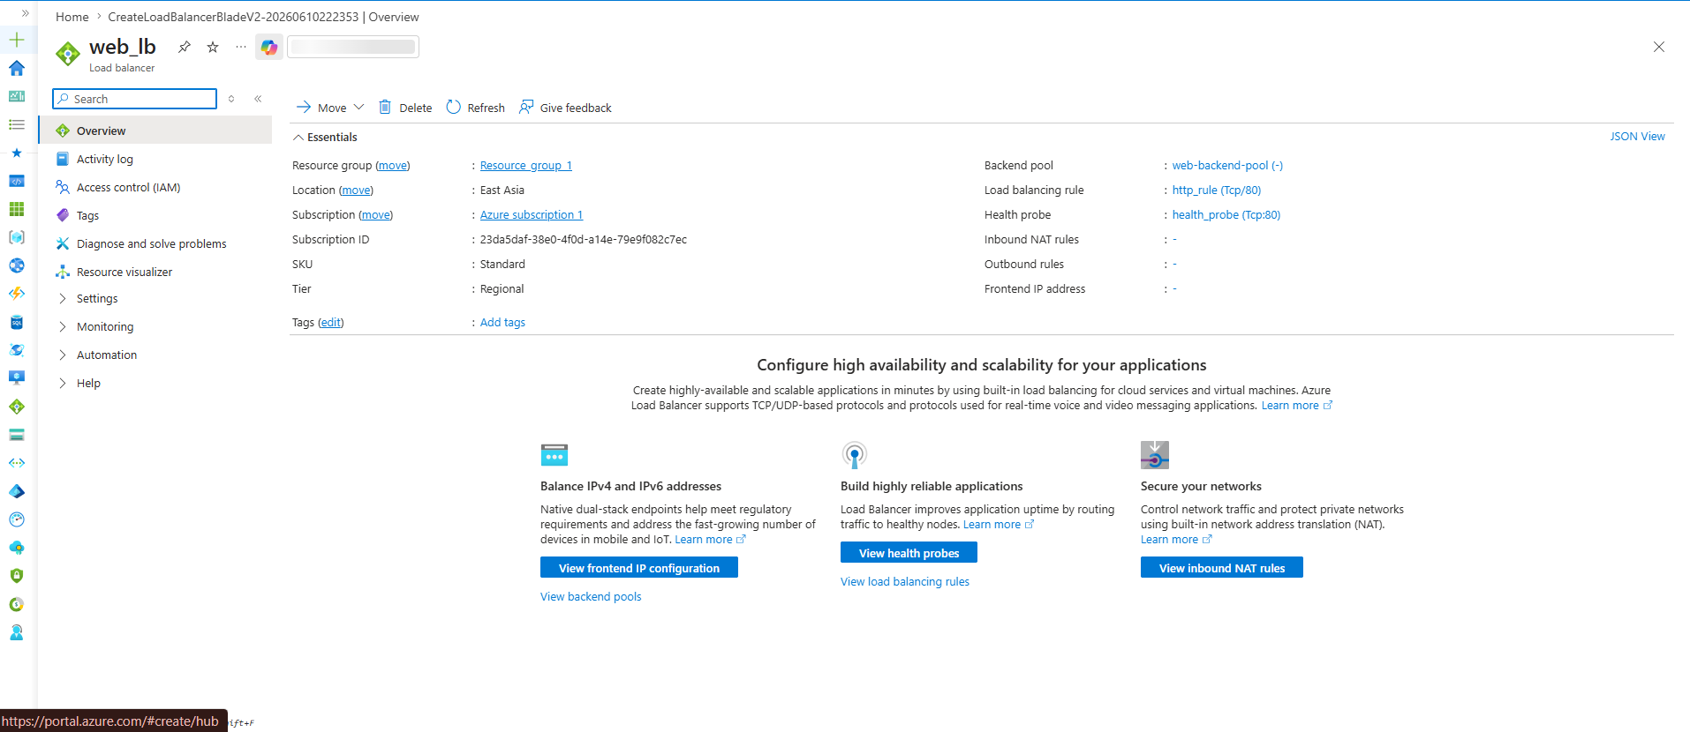Memory Trick
NAT Gateway
= Private VM → Internet
Load Balancer Outbound Rule
= Backend Pool VM → Internet using LB Public IP
Inbound NAT Rule
= Internet → Specific VM
Load Balancing Rule
= Internet → Multiple VMs
Why We Use Azure Load Balancer
- Azure Load Balancer distributes incoming traffic across multiple virtual machines.
- It prevents a single VM from becoming overloaded.
- It improves application availability by routing traffic only to healthy VMs.
- If one VM fails, traffic is automatically redirected to other healthy VMs.
- It helps applications continue running without downtime.
- It supports horizontal scaling by allowing additional VMs to be added to the backend pool.
- It improves fault tolerance and reliability.
- Health Probes continuously monitor backend VM health.
- Load Balancing Rules determine how incoming traffic is distributed.
- Commonly used for web applications, APIs, and enterprise workloads.
Simple Architecture
Users
↓
Frontend IP
↓
Load Balancer
↓
VM-1
↓
VM-2
↓
VM-3
Key Point
Load Balancer
→ Decides WHICH VM receives the traffic.
NSG
→ Decides WHETHER traffic is allowed.
Health Probe
→ Decides WHICH VMs are healthy.
Load Balancing Rule
→ Decides HOW traffic is forwarded.

Its primary goals are:
High Availability ✅
Fault Tolerance ✅
Traffic Distribution ✅
Scalability ✅
So in interviews, say:
"Azure Load Balancer distributes traffic across multiple backend VMs to provide high availability, fault tolerance, and scalability while ensuring the application remains available even if individual VMs fail."

What is Horizontal Scaling?
Horizontal Scaling means:
Traffic Increases
↓
Automatically Create More VMs
Example:
Morning:
VM-1
VM-2
Evening (High Traffic):
VM-1
VM-2
VM-3
VM-4
VM-5
Azure creates additional VMs automatically.

What Service Provides That?
Usually:
Virtual Machine Scale Set (VMSS)
Architecture:
Users
↓
Load Balancer
↓
VM Scale Set
VM-1
VM-2
VM-3
When CPU reaches:
80%
Azure can automatically add:
VM-4
VM-5
This is Auto Scaling.

Relationship
Load Balancer
+
VM Scale Set
is the common enterprise architecture.
Load Balancer:
Distributes traffic.
VM Scale Set:
Creates and removes VMs automatically.

Azure Load Balancer itself does not perform horizontal scaling. It distributes traffic among existing backend resources. Horizontal scaling is typically achieved using Virtual Machine Scale Sets (VMSS), which automatically add or remove virtual machines based on demand.
Load Balancer = Traffic Distribution
VMSS = Horizontal Scaling

